Obrazec št. 2a: Načrt razpolaganja z zemljišči za leto 2026 - Rebalans 1; dopolnitev september 2026

LASTNIK: Mestna občina Nova Gorica

Zap. št. | Upravljavec |  | Samoupravna lokalna skupnost | Šifra in ime katastrske občine | Parcelna številka |  | Površina parcele v m2 | Ocenjena, posplošena ali orientacijska vrednost nepremičnine v EUR
1 | MONG |  | MONG | 2336 Branik | 4903/11 |  | 100 | 1.400,00
2 | MONG |  | MONG | 2335 Dornberk | 502/4 |  | 2200 | 64.000,00
3 | MONG |  | MONG | 2335 Dornberk | 502/91 |  | 1148 | 33.000,00
4 | MONG |  | MONG | 2335 Dornberk | 253/5 |  | 261 | 5.500,00
5 | MONG |  | MONG | 2335 Dornberk | 252/7 |  | 63 | 3.800,00
6 | MONG |  | MONG | 2335 Dornberk | 233/7 |  | 68 | 3.900,00
7 | MONG |  | MONG | 2302 Kromberk | 1183/23 |  | 4.064 | 280.400,00
8 | MONG |  | MONG | 2302 Kromberk | 1183/24 |  | 4.283 | 295.500,00
9 | MONG |  | MONG | 2302 Kromberk | 1183/26 |  | 2,142 | 147.800,00
10 | MONG |  | MONG | 2302 Kromberk | 1183/28 |  | 2,142 | 147.800,00
11 | MONG |  | MONG | 2302 Kromberk | 238 |  | 755 | 52.800,00
12 | MONG |  | MONG | 2302 Kromberk | 239/1 |  | 292 | 20.440,00
13 | MONG |  | MONG | 2302 Kromberk | 240 |  | 224 | 15.680,00
14 | MONG |  | MONG | 2302 Kromberk | 420/291 |  | 247 | 18.500,00
15 | MONG |  | MONG | 2306 Rožna Dolina | 289/2 |  | 3.000 | 30.000,00
16 | MONG |  | MONG | 2303 Solkan | 1536/1 |  | 257 | 17.000,00
17 | MONG |  | MONG | 2309 Šmihel | 5227/7 |  | 87 | 2.100,00
18 | MONG |  | MONG | 2309 Šmihel | 5229/1 |  | 42 | 1.100,00
19 | MONG |  | MONG | 2311 Vitovlje | 2169/3 |  | 69 | 3.000,00
20 | MONG |  | MONG | 2303 Solkan | 863/38 |  | 24 | 1.440,00
21 |  | MONG | MONG | 2304 Nova Gorica | 1264/4 | 116 |  | 5.800,00
22 |  | MONG | MONG | 2304 Nova Gorica | 1263/3 | 148 |  | 7.400,00
23 |  | MONG | MONG | 2304 Nova Gorica | 1263/21 | 290 |  | 14.500,00
24 |  | MONG | MONG | 2304 Nova Gorica | 1263/20 | 177 |  | 8.850,00
25 |  | MONG | MONG | 2304 Nova Gorica | 1263/17 | 204 |  | 10.200,00
26 |  | MONG | MONG | 2304 Nova Gorica | 1263/16 | 404 |  | 20.200,00
27 |  | MONG | MONG | 2336 Branik | 4892/22 | 27 |  | 928,00
28 |  | MONG | MONG | 2336 Branik | 4891/18 | 5 |  | 172,00
29 |  | MONG | MONG | 2336 Branik | 4891/11 | 20 |  | 687,00
30 |  | MONG | MONG | 2336 Branik | 4892/12 | 18 |  | 618,00
31 |  | MONG | MONG | 2336 Branik | 4894/2 | 4 |  | 137,00
32 |  | MONG | MONG | 2336 Branik | 1077/5 | 2 |  | 69,00
33 |  | MONG | MONG | 2337 Bukovo | *73/2 | 54 |  | 7,00
34 |  | MONG | MONG | 2337 Bukovo | 325/54 | 533 |  | 67,00
35 |  | MONG | MONG | 2337 Bukovo | 366/3 | 3284 |  | 411,00
36 |  | MONG | MONG | 2337 Bukovo | 463/20 | 127 |  | 16,00
37 |  | MONG | MONG | 2337 Bukovo | 463/50 | 4002 |  | 500,00
38 |  | MONG | MONG | 2337 Bukovo | 463/52 | 653 |  | 82,00
39 |  | MONG | MONG | 2337 Bukovo | 463/53 | 29 |  | 4,00
40 |  | MONG | MONG | 2337 Bukovo | 463/54 | 63 |  | 8,00
41 |  | MONG | MONG | 2337 Bukovo | 463/55 | 238 |  | 30,00
42 |  | MONG | MONG | 2337 Bukovo | 463/56 | 1664 |  | 208,00
43 |  | MONG | MONG | 2337 Bukovo | 463/57 | 10 |  | 1,00
44 |  | MONG | MONG | 2337 Bukovo | 463/62 | 352 |  | 44,00
45 |  | MONG | MONG | 2337 Bukovo | 468/2 | 1623 |  | 203,00
46 |  | MONG | MONG | 2337 Bukovo | 474/2 | 82 |  | 10,00
47 |  | MONG | MONG | 2337 Bukovo | 477/3 | 57 |  | 7,00
48 |  | MONG | MONG | 2337 Bukovo | 478/1 | 1374 |  | 172,00
49 |  | MONG | MONG | 2337 Bukovo | 478/2 | 2516 |  | 315,00
50 |  | MONG | MONG | 2337 Bukovo | 484/2 | 109 |  | 14,00
51 |  | MONG | MONG | 2337 Bukovo | 516/4 | 3394 |  | 424,00
52 |  | MONG | MONG | 2309 Šmihel | 5223/2 | 7 |  | 14,00
53 |  | MONG | MONG | 2309 Šmihel | 5223/3 | 15 |  | 30,00
54 |  | MONG | MONG | 2309 Šmihel | 5223/4 | 38 |  | 76,00
55 |  | MONG | MONG | 2309 Šmihel | 5223/5 | 196 |  | 1.112,00
56 |  | MONG | MONG | 2304 Nova Gorica | 1348/3 | 36 |  | 3.600,00
57 |  | MONG | MONG | 2304 Nova Gorica | 1889/26 | 340 |  | 10.000,00
58 |  | MONG | MONG | 2306 Rožna Dolina | 172/13 (¹/₂) | 190 |  | 8.260,00
59 |  | MONG | MONG | 2303 Solkan | 988/19 | 165 |  | 13.000,00
60 |  | MONG | MONG | 2303 Solkan | 1351/38 | 142 |  | 9.000,00
61 |  | MONG | MONG | 2312 Osek | 2640/144 | 468 |  | 28.000,00
62 |  | MONG | MONG | 2335 Dornberk | 233/33 | 1 |  | 50,00
63 |  | MONG | MONG | 2306 Rožna Dolina | 133/2 | 139 |  | 10.000,00
64 |  | MONG | MONG | 2306 Rožna Dolina | 133/3 | 12 |  | 860,00
65 |  | MONG | MONG | 2296 Lokovec | 841/6 | 162 |  | 500,00
66 |  | MONG | MONG | 2296 Lokovec | 841/7 | 1.043 |  | 3.000,00
67 |  | MONG | MONG | 2296 Lokovec | 841/8 | 140 |  | 500,00
68 |  | MONG | MONG | 2296 Lokovec | 841/16 | 107 |  | 400,00
69 |  | MONG | MONG | 2296 Lokovec | 841/17 | 51 |  | 200,00
70 |  | MONG | MONG | 2296 Lokovec | 841/18 | 74 |  | 250,00
71 |  | MONG | MONG | 2296 Lokovec | 841/19 | 36 |  | 100,00
72 |  | MONG | MONG | 2296 Lokovec | 841/11 | 283 |  | 600,00
73 |  | MONG | MONG | 2301 Ravnica | 1271/3 | 211 |  | 6.000,00
74 |  | MONG | MONG | 2295 Banjšice | 2241 | 355 |  | 4.000,00
75 |  | MONG | MONG | 2295 Banjšice | 2244/2 | 964 |  | 1.500,00
76 |  | MONG | MONG | 2304 Nova Gorica | 944/5 | 974 |  | 76.500,00
77 |  | MONG | MONG | 1650 Babna Polica | 466/23 | 11.906 |  | 9.880,00
78 |  | MONG | MONG | 1650 Babna Polica | 466/24 | 6.513 |  | 5.670,00
79 |  | MONG | MONG | 1650 Babna Polica | 466/25 | 449 |  | 430,00
80 |  | MONG | MONG | 1650 Babna Polica | 466/26 | 3.157 |  | 2.880,00
81 |  | MONG | MONG | 1650 Babno Polje | 133/102 | 500 |  | 480,00
82 |  | MONG | MONG | 1651 Babno Polje | 133/103 | 10.920 |  | 9.060,00
83 |  | MONG | MONG | 1651 Babno Polje | 133/104 | 1.250 |  | 1.140,00
84 |  | MONG | MONG | 1651 Babno Polje | 808 | 19.139 |  | 15.900,00
85 |  | MONG | MONG | 2302 Kromberk | 1297/7 | 534 |  | 48.100,00
86 |  | MONG | MONG | 2302 Kromberk | 1183/48 | 877 |  | 41.500,00
87 |  | MONG | MONG | 2306 Rožna Dolina | 397/4 | 18.914 |  | 32.500,00
88 |  | MONG | MONG | 2295 Banjšice | 1972/1 | 194 |  | 2.700,00
89 |  | MONG | MONG | 2302 Kromberk | 401/12 | 52 |  | 1.144,00
90 |  | MONG | MONG | 2302 Kromberk | 401/13 | 17 |  | 374,00
91 |  | MONG | MONG | 2302 Kromberk | 401/17 | 50 |  | 1.100,00
92 |  | MONG | MONG | 2302 Kromberk | 402/16 | 13 |  | 286,00
93 |  | MONG | MONG | 2302 Kromberk | 402/35 | 794 |  | 17.468,00
94 |  | MONG | MONG | 2301 Ravnica | 1219 | 111 |  | 250,00
95 |  | MONG | MONG | 2304 Nova Gorica | 1464/45 | 16 |  | 1.790,00
96 |  | MONG | MONG | 2304 Nova Gorica | 1464/58 | 12 |  | 1.350,00
97 |  | MONG | MONG | 2335 Dornberk | 500/7 | 275 |  | 8.715,00
98 |  | MONG | MONG | 2320 Prvačina | 1524/25 | 89 |  | 3.915,00
99 |  | MONG | MONG | 2335 Dornberk | 29/2 | 75 |  | 3.274,00
100 |  | MONG | MONG | 2304 Nova Gorica | 313/8 | 67 |  | 6.349,00
101 |  | MONG | MONG | 2304 Nova Gorica | 119/3 | 27 |  | 3.450,00
102 |  | MONG | MONG | 2301 Ravnica | 1241/6 | 29 |  | 780,00
103 |  | MONG | MONG | 2301 Ravnica | 1241/7 | 34 |  | 910,00
104 |  | MONG | MONG | 2306 Rožna Dolina | 306 | 170 |  | 6.800,00
105 |  | MONG | MONG | 2295 Banjšice | 2519/15 | 260 |  | 3.650,00
106 |  | MONG | MONG | 2295 Banjšice | 2527/16 | 114 |  | 1.600,00
107 |  | MONG | MONG | 2295 Banjšice | 2527/17 | 94 |  | 1.300,00
108 |  | MONG | MONG | 2295 Banjšice | 2525/18 | 38 |  | 550,00
109 |  | MONG | MONG | 2295 Banjšice | 2527/19 | 53 |  | 750,00
110 |  | MONG | MONG | 2295 Banjšice | 2527/20 | 46 |  | 650,00
111 |  | MONG | MONG | 2295 Banjšice | 2500/33 | 460 |  | 6.450,00
112 |  | MONG | MONG | 2295 Banjšice | 2536/16 | 42 |  | 800,00
113 |  | MONG | MONG | 2304 Nova Gorica | 1464/59 | 10 |  | 540,00
114 |  | MONG | MONG | 2294 Bate | 2933/5 | 110 |  | 2.200,00
115 |  | MONG | MONG | 2304 Nova Gorica | 1889/26 | 340 |  | 23.800,00
116 |  | MONG | MONG | 2304 Nova Gorica | 1889/28 | 31 |  | 2.170,00
117 |  | MONG | MONG | 2304 Nova Gorica | 658/17 | 5.056 |  | 1.508.590,00
118 |  | MONG | MONG | 2304 Nova Gorica | 263/5 | 6.468 |  | 162.450,00
Dopolnitev september 2026
119 |  | MONG | MONG | 2335 Dornberk | 7687/5 | 74 |  | 1.410,00
120 |  | MONG | MONG | 2313 Šempas | 5450/1 | 217 |  | 5.160,00
121 |  | MONG | MONG | 2303 Solkan | 2240/19 | 12 |  | 840,00
122 |  | MONG | MONG | 2302 Kromberk | 1030/15 | 17 |  | 510,00
123 |  | MONG | MONG | 2293 Grgar | 410/8 | 75 |  | 2.250,00
124 |  | MONG | MONG | 2293 Grgar | 411/10 | 114 |  | 3.420,00
125 |  | MONG | MONG | 2310 Ozeljan | 3595/15 | 2.935 |  | 47.800,00
126 |  | MONG | MONG | 2310 Ozeljan | 3595/16 | 207 |  | 3.440,00
127 |  | MONG | MONG | 2310 Ozeljan | 3595/17 | 162 |  | 2.690,00
128 |  | MONG | MONG | 2310 Ozeljan | 3595/18 | 1.142 |  | 19.000,00
129 |  | MONG | MONG | 2312 Osek | 1545/13 | 131 |  | 440,00
130 |  | MONG | MONG | 2303 Solkan | 1355/5 | 402 |  | 30.563,00

SKUPAJ: 3.456.014,00 EUR

Načrt razpolaganja z nepremičnim premoženjem za leto 2026; Rebalans 1 se dopolni s prodajo funkcionalnega zemljišča k stanovanjskemu objektu v Dornberku. Nadalje se v načrt razpolaganja vključi prodaja zemljišča za potrebe funkcionalne zaokrožitve nepremičnin s parc. št. *538, parc. št. 777/2 ter parc. št. 776/8 vse k.o. 2313 Šempas. Načrt razpolaganja se dopolni tudi s prodajo nepremičnine,ki predstavlja funkcionalno zemljišče k poslovno-stanovanjskemu objektu na Soški cesti v Solkanu. Načrt razpolaganja se dopolni tudi s prodajo manjšega zemljišča ob stanovanjskem objektu na Vardi. V načrt razpolaganja se vključi tudi prodaja nepremičnin, ki v naravi predstavljata funkcionalni zemljišči, ki služita potrebam dvostanovanjskega objekta v Grgarju. Načrt razpolaganja se dopolni tudi s prodajo kompleksa stavbnih zemljišč na Okroglici. V načrt razpolaganja se vključi tudi prodajo zemljišča za potrebe izvedbe dostopa do kmetijskih zemljišč v Oseku. Načrt razpolaganja pa se dopolni tudi s prodajo solastniškega deleža do 15/16 na nepremičnini v ulici Pot na Breg v Solkanu.

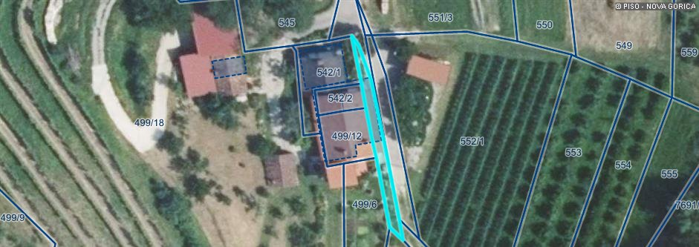
Zap. št. 119

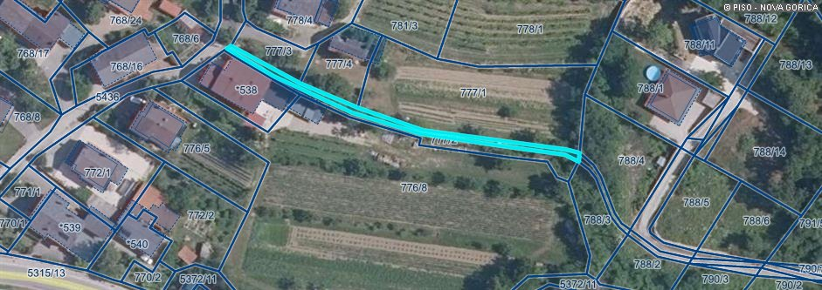
Zap. št. 120

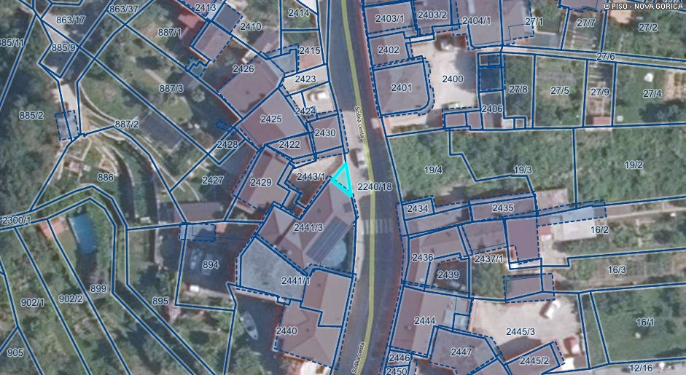
Zap. št. 121
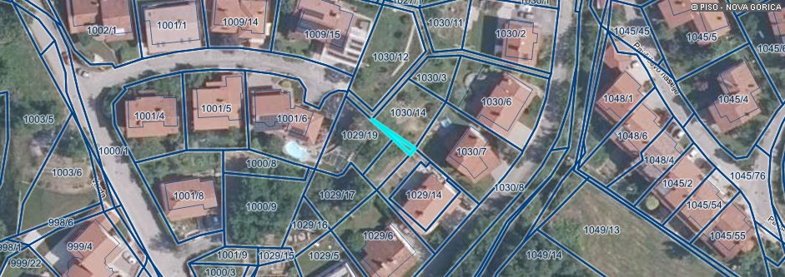
Zap. št. 122

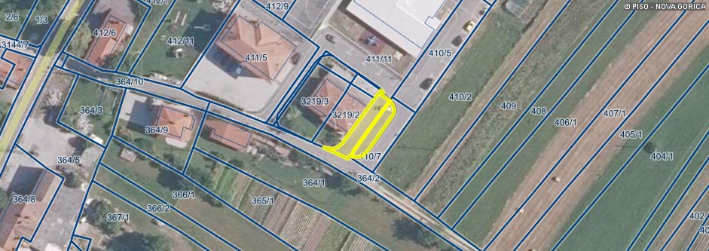
Zap. št. 123-124

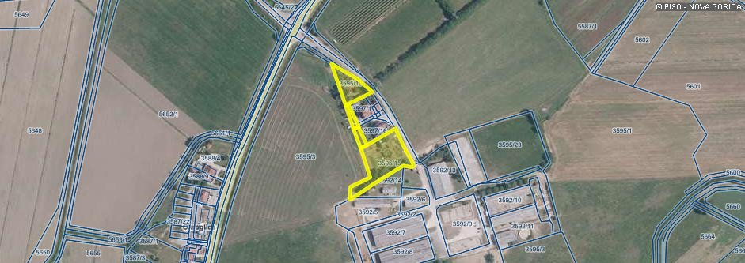
Zap. št. 125 -128

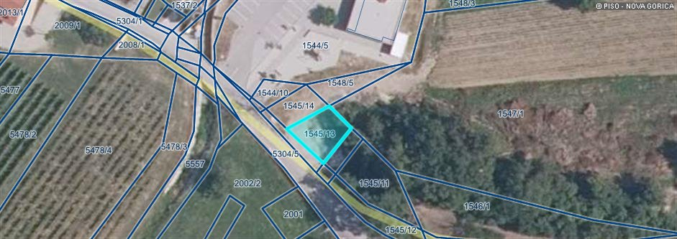
Zap. št. 129

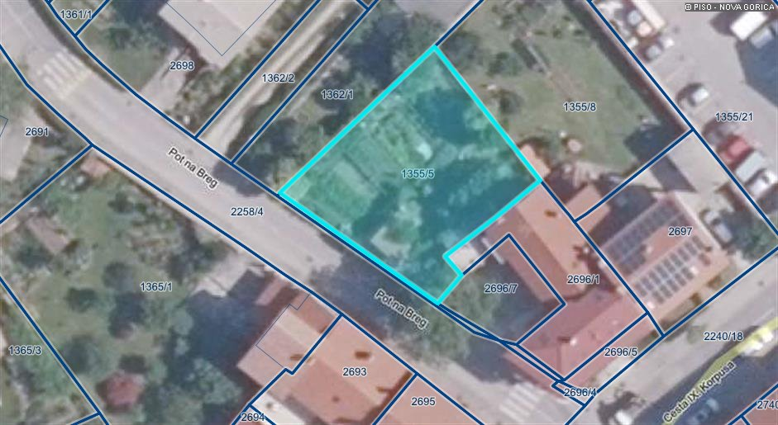
Zap. št. 130

