Obrazec št. 2a: Načrt razpolaganja z nepremičnim premoženjem za leto 2025 – REBALANS 1; dopolnitev
december 2025

LASTNIK: Mestna občina Nova Gorica
Zap. št. | Upravljavec |  | Samoupravna lokalna skupnost | Šifra in ime katastrske občine | Parcelna številka |  | Površina parcele v m2 | Ocenjena, posplošena ali orientacijska vrednost nepremičnine v EUR
1 | MONG |  | MONG | 2336 Branik | 4903/11 |  | 100 | 1.400,00
2 | MONG |  | MONG | 2336 Branik | 4903/20 |  | 68 | 2.300,00
3 | MONG |  | MONG | 2297 Čepovan | 2353/16 |  | 36 | 2.300,00
4 | MONG |  | MONG | 2335 Dornberk | 502/4 |  | 2200 | 64.000,00
5 | MONG |  | MONG | 2335 Dornberk | 502/91 |  | 1148 | 33.000,00
6 | MONG |  | MONG | 2335 Dornberk | 253/5 |  | 261 | 5.500,00
7 | MONG |  | MONG | 2335 Dornberk | 252/7 |  | 63 | 3.800,00
8 | MONG |  | MONG | 2335 Dornberk | 233/7 |  | 68 | 3.900,00
9 | MONG |  | MONG | 2293 Grgar | 3132/17 |  | 54 | 1.600,00
10 | MONG |  | MONG | 2302 Kromberk | 1183/23 |  | 4.064 | 280.400,00
11 | MONG |  | MONG | 2302 Kromberk | 1183/24 |  | 4.283 | 295.500,00
12 | MONG |  | MONG | 2302 Kromberk | 1183/26 |  | 2,142 | 147.800,00
13 | MONG |  | MONG | 2302 Kromberk | 1183/28 |  | 2,142 | 147.800,00
14 | MONG |  | MONG | 2302 Kromberk | 1183/30 |  | 4.206 | 290.200,00
15 | MONG |  | MONG | 2302 Kromberk | 420/183 |  | 479 | 55.000,00
16 | MONG |  | MONG | 2302 Kromberk | 308/25 |  | 745 | 38.000,00
17 | MONG |  | MONG | 2302 Kromberk | 308/26 |  | 1347 | 42.000,00
18 | MONG |  | MONG | 2302 Kromberk | 238 |  | 755 | 52.800,00
19 | MONG |  | MONG | 2302 Kromberk | 239/1 |  | 292 | 20.440,00
20 | MONG |  | MONG | 2302 Kromberk | 240 |  | 224 | 15.680,00
21 | MONG |  | MONG | 2302 Kromberk | 420/291 |  | 247 | 18.500,00
22 | MONG |  | MONG | 2304 Nova Gorica | 1464/42 |  | 15 | 820,00
23 | MONG |  | MONG | 2304 Nova Gorica | 1464/45 |  | 16 | 874,00
24 | MONG |  | MONG | 2304 Nova Gorica | 1464/58 |  | 12 | 658,00
25 | MONG |  | MONG | 2304 Nova Gorica | 1464/59 |  | 10 | 540,00
26 | MONG |  | MONG | 2306 Rožna Dolina | 133/2 |  | 139 | 4.500,00
27 | MONG |  | MONG | 2306 Rožna Dolina | 439/1 |  | 634 | 29.000,00
28 | MONG |  | MONG | 2306 Rožna Dolina | 430/2 |  | 188 | 3.000,00
29 | MONG |  | MONG | 2306 Rožna Dolina | 430/3 |  | 62 | 1.200,00
30 | MONG |  | MONG | 2306 Rožna Dolina | 423/5 |  | 259 | 4.500,00
31 | MONG |  | MONG | 2306 Rožna Dolina | 423/6 |  | 162 | 2.700,00
32 | MONG |  | MONG | 2306 Rožna Dolina | 289/2 |  | 3.000 | 30.000,00
33 | MONG |  | MONG | 2303 Solkan | 1536/1 |  | 257 | 17.000,00
34 | MONG |  | MONG | 2309 Šmihel | 5227/7 |  | 87 | 2.100,00
35 | MONG |  | MONG | 2309 Šmihel | 5229/1 |  | 42 | 1.100,00
36 | MONG |  | MONG | 2311 Vitovlje | 2169/3 |  | 69 | 3.000,00
37 | MONG |  | MONG | 2299 Lokve | 297/4 |  | 830 | 43.000,00
38 | MONG |  | MONG | 2336 Branik | 4903/19 |  | 25 | 1.100,00
39 | MONG |  | MONG | 2303 Solkan | 863/36 |  | 43 | 2.580,00
40 | MONG |  | MONG | 2303 Solkan | 863/38 |  | 24 | 1.440,00
41 | MONG |  | MONG | 2320 Prvačina | 1525/18 |  | 155 | 0,00
42 | MONG |  | MONG | 2320 Prvačina | 162/5 |  | 224 | 0,00
43 | MONG |  | MONG | 2320 Prvačina | 1525/20 |  | 47 | 0,00
44 | MONG |  | MONG | 2320 Prvačina | 141/11 |  | 504 | 0,00
45 | MONG |  | MONG | 2320 Prvačina | 2088/2 |  | 10 | 0,00
46 | MONG |  | MONG | 2320 Prvačina | 2089/2 |  | 77 | 0,00
47 | MONG |  | MONG | 2320 Prvačina | 2090/2 |  | 170 | 0,00
48 | MONG |  | MONG | 2320 Prvačina | 2091/2 |  | 387 | 0,00
49 | MONG |  | MONG | 2320 Prvačina | 2092/2 |  | 74 | 0,00
50 |  | MONG | MONG | 2034 Nova Gorica | 960 |  | 869 | 4.345,00
51 |  | MONG | MONG | 2304 Nova Gorica | 961 | 999 |  | 4.995,00
52 |  | MONG | MONG | 2304 Nova Gorica | 1264/4 | 116 |  | 5.800,00
53 |  | MONG | MONG | 2304 Nova Gorica | 1263/3 | 148 |  | 7.400,00
54 |  | MONG | MONG | 2304 Nova Gorica | 1263/21 | 290 |  | 14.500,00
55 |  | MONG | MONG | 2304 Nova Gorica | 1263/20 | 177 |  | 8.850,00
56 |  | MONG | MONG | 2304 Nova Gorica | 1263/17 | 204 |  | 10.200,00
57 |  | MONG | MONG | 2304 Nova Gorica | 1263/16 | 404 |  | 20.200,00
58 |  | MONG | MONG | 2336 Branik | 4892/22 | 27 |  | 928,00
59 |  | MONG | MONG | 2336 Branik | 4891/18 | 5 |  | 172,00
60 |  | MONG | MONG | 2336 Branik | 4891/11 | 20 |  | 687,00
61 |  | MONG | MONG | 2336 Branik | 4892/12 | 18 |  | 618,00
62 |  | MONG | MONG | 2336 Branik | 4894/2 | 4 |  | 137,00
63 |  | MONG | MONG | 2336 Branik | 1077/5 | 2 |  | 69,00
64 |  | MONG | MONG | 2337 Bukovo | *73/2 | 54 |  | 7,00
65 |  | MONG | MONG | 2337 Bukovo | 325/54 | 533 |  | 67,00
66 |  | MONG | MONG | 2337 Bukovo | 366/3 | 3284 |  | 411,00
67 |  | MONG | MONG | 2337 Bukovo | 463/20 | 127 |  | 16,00
68 |  | MONG | MONG | 2337 Bukovo | 463/50 | 4002 |  | 500,00
69 |  | MONG | MONG | 2337 Bukovo | 463/52 | 653 |  | 82,00
70 |  | MONG | MONG | 2337 Bukovo | 463/53 | 29 |  | 4,00
71 |  | MONG | MONG | 2337 Bukovo | 463/54 | 63 |  | 8,00
72 |  | MONG | MONG | 2337 Bukovo | 463/55 | 238 |  | 30,00
73 |  | MONG | MONG | 2337 Bukovo | 463/56 | 1664 |  | 208,00
74 |  | MONG | MONG | 2337 Bukovo | 463/57 | 10 |  | 1,00
75 |  | MONG | MONG | 2337 Bukovo | 463/62 | 352 |  | 44,00
76 |  | MONG | MONG | 2337 Bukovo | 468/2 | 1623 |  | 203,00
77 |  | MONG | MONG | 2337 Bukovo | 474/2 | 82 |  | 10,00
78 |  | MONG | MONG | 2337 Bukovo | 477/3 | 57 |  | 7,00
79 |  | MONG | MONG | 2337 Bukovo | 478/1 | 1374 |  | 172,00
80 |  | MONG | MONG | 2337 Bukovo | 478/2 | 2516 |  | 315,00
81 |  | MONG | MONG | 2337 Bukovo | 484/2 | 109 |  | 14,00
82 |  | MONG | MONG | 2337 Bukovo | 516/4 | 3394 |  | 424,00
83 |  | MONG | MONG | 2303 Solkan | 2481/2 | 32 |  | 2.000,00
84 |  | MONG | MONG | 2302 Kromberk | 1059/3 | 603 |  | 36.000,00
85 |  | MONG | MONG | 2301 Ravnica | 1234/58 | 800 |  | 30.000,00
86 |  | MONG | MONG | Šmihel | 5223/2 | 7 |  | 14,00
87 |  | MONG | MONG | Šmihel | 5223/3 | 15 |  | 30,00
88 |  | MONG | MONG | Šmihel | 5223/4 | 38 |  | 76,00
89 |  | MONG | MONG | Šmihel | 5223/5 | 196 |  | 1.112,00
90 |  | MONG | MONG | Nova Gorica | 1348/2 | 37 |  | 3.700,00
91 |  | MONG | MONG | Nova Gorica | 1348/3 | 36 |  | 3.600,00
92 |  | MONG | MONG | Nova Gorica | 1889/26 | 340 |  | 10.000,00
93 |  | MONG | MONG | Mravljevi | 3524/24 | 92 |  | 400,00
94 |  | MONG | MONG | Grgar | 3139/8 | 182 |  | 6.792,00
95 |  | MONG | MONG | Kromberk | 1319/7 | 131 |  | 7.800,00
96 |  | MONG | MONG | Rožna Dolina | 172/13 (1/2) | 190 |  | 8.260,00
97 |  | MONG | MONG | Branik | 4905/32 | 23 |  | 700,00
98 |  | MONG | MONG | Solkan | 988/19 | 165 |  | 13.000,00
99 |  | MONG | MONG | Solkan | 1351/38 | 142 |  | 9.000,00
100 |  | MONG | MONG | Dornberk | 7672/2 | 8 |  | 300,00
101 |  | MONG | MONG | Osek | 2640/144 | 468 |  | 28.000,00
102 |  | MONG | MONG | Grgar | 264 | 101 |  | 3.030,00
103 |  | MONG | MONG | Grgar | 265 | 666 |  | 20.000,00
104 |  | MONG | MONG | Stara Gora | 82/55 | 2500 |  | 8.000,00
105 |  | MONG | MONG | Nova Gorica | 598/5 | 74 |  | 5.920,00
106 |  | MONG | MONG | Nova Gorica | 599/6 | 4 |  | 320,00
107 |  | MONG | MONG | Branik | 1919/6 | 76 |  | 10.000,00
108 |  | MONG | MONG | Dornberk | 233/3 | 1 |  | 50,00
109 |  | MONG | MONG | Šmaver | 335/8 | 2.253 |  | 90.000,00
110 |  | MONG | MONG | Rožna Dolina | 133/2 | 139 |  | 10.000,00
111 |  | MONG | MONG | Rožna Dolina | 133/3 | 12 |  | 860,00
112 |  | MONG | MONG | Lokovec | 841/6 | 162 |  | 500,00
113 |  | MONG | MONG | Lokovec | 841/7 | 1.043 |  | 3.000,00
114 |  | MONG | MONG | Lokovec | 841/8 | 140 |  | 500,00
115 |  | MONG | MONG | Lokovec | 841/16 | 107 |  | 400,00
116 |  | MONG | MONG | Lokovec | 841/17 | 51 |  | 200,00
117 |  | MONG | MONG | Lokovec | 841/18 | 74 |  | 250,00
118 |  | MONG | MONG | Lokovec | 841/19 | 36 |  | 100,00
119 |  | MONG | MONG | Lokovec | 841/11 | 283 |  | 600,00
120 |  | MONG | MONG | Ravnica | 1271/3 | 211 |  | 6.000,00
121 |  | MONG | MONG | Banjšice | 2241 | 355 |  | 4.000,00
122 |  | MONG | MONG | Banjšice | 2244/2 | 964 |  | 1.500,00
123 |  | MONG | MONG | Nova Gorica | 944/5 | 974 |  | 76.500,00
Dopolnitev december 2025
124 |  | MONG | MONG | Dornberk | 6534/1 | 2.574 |  | 4.616,00
125 |  | MONG | MONG | Dornberk | 6535 | 1.364 |  | 1.440,00

SKUPAJ: 2.140.826,00 EUR

Načrt razpolaganja z nepremičnim premoženjem za leto 2025; Rebalans 1 se dopolni z odtujitvijo nepremičnin v sklopu zamenjave zemljišč za izvedbo investicije Regulacije struge potoka Potok.

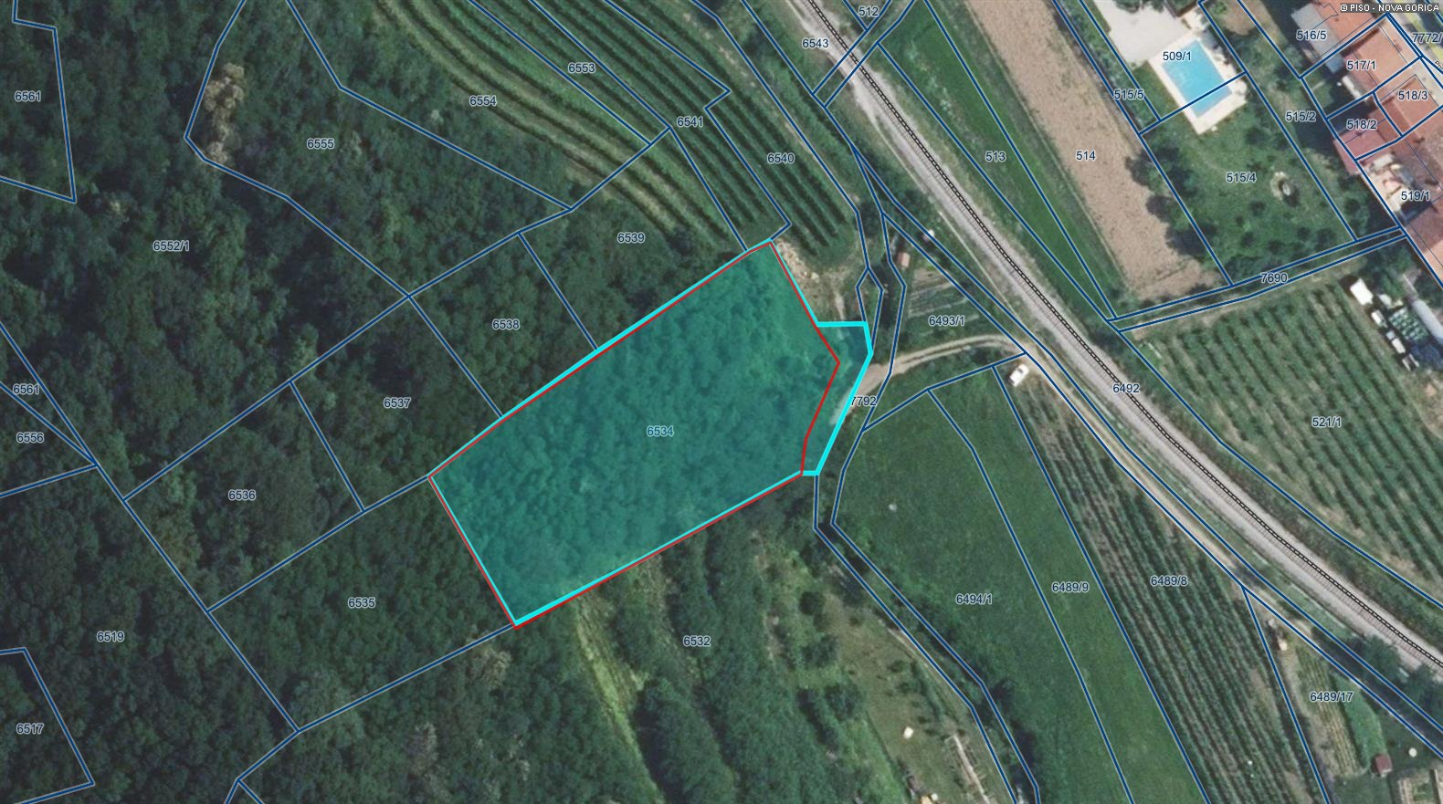
Zap. št. 124

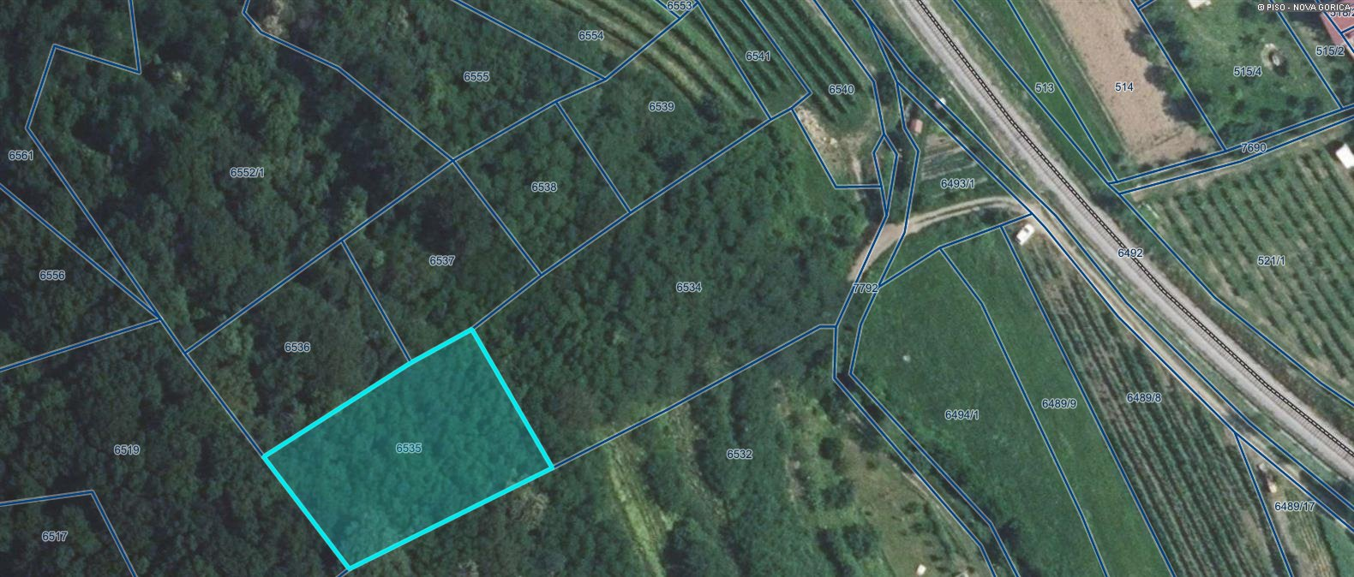
Zap. št. 125

